**Honor Board Accord: Fair or Foul?**

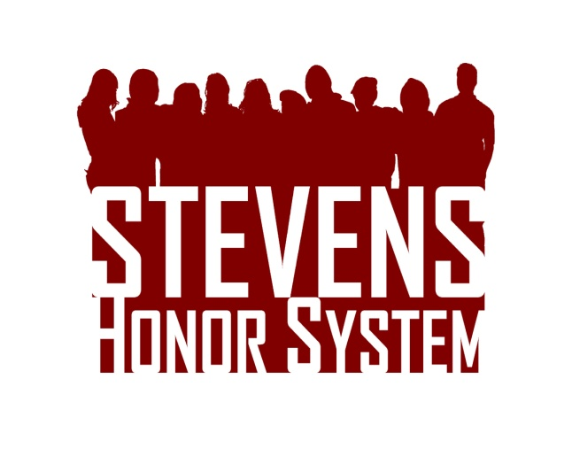Read the fake case presented to the honor board and determine whether a violation has occurred and what penalties should be assigned. Please support your reasoning. Visit [stevens.edu/honor](http://stevens.edu/honor) for the Honor System Bylaws and Penalty Matrix.  Drop your answers in Stevens mailbox S-1475 or email them to [honor@stevens.edu](mailto:honor@stevens.edu) by January 31st. The top response will receive a $50 Visa gift card!

While waiting for the TA to come around during an Engineering Design II class, a student knowledgeable in the course offers to help a group having difficulty. After realizing the other group’s mistakes for their robot, the helpful student begins reassembling the robot and its components, using power tools in the process. Twenty minutes later, the TA finally comes over and complains that this individual is not with his assigned group. All involved parties are reported to the professor and the Honor Board. Should any students be found guilty of an Honor System violation? If yes, what penalty should be assigned?